**Configuration management:**

1. **GitHub:**

GitHub is an online version control service which stores our work in versioned fashion. We can revert to any version at any point in time. Multiple users can use a repository to store their work.

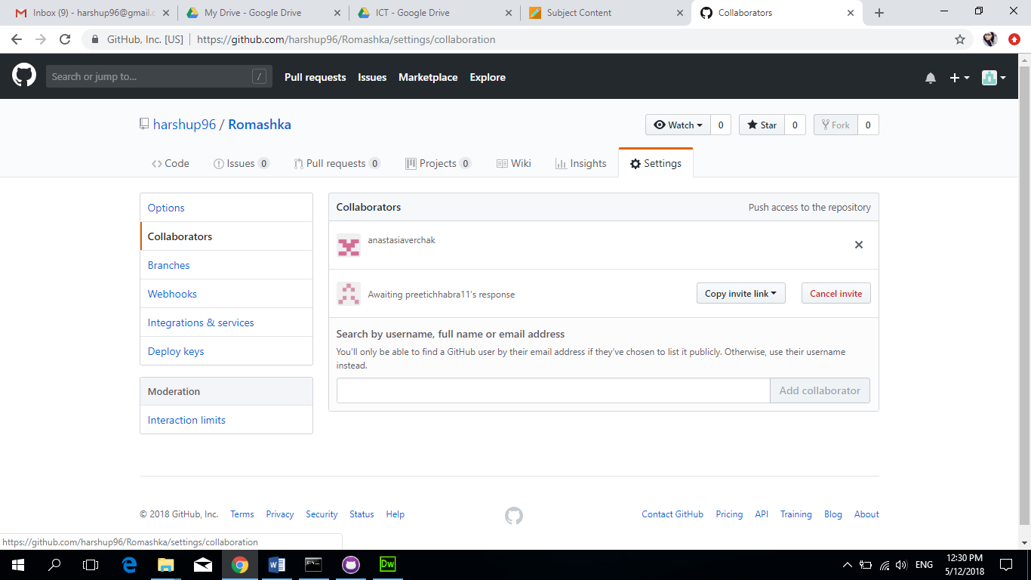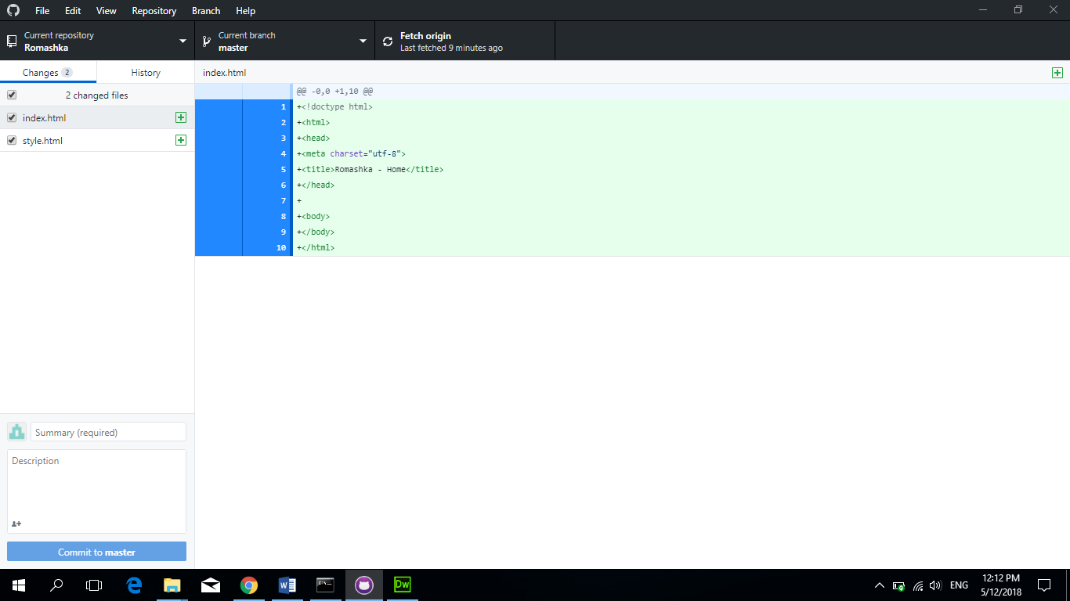

1. **Google Drive:**

Google drive is a cloud storage solution for Internet giant Google. We can use it to collaborate and work on documents simultaneously in real time. Initially, Google provides 15GB of free space and it can extended with subscription. We used Google Drive to share large files initially then, we started using git.

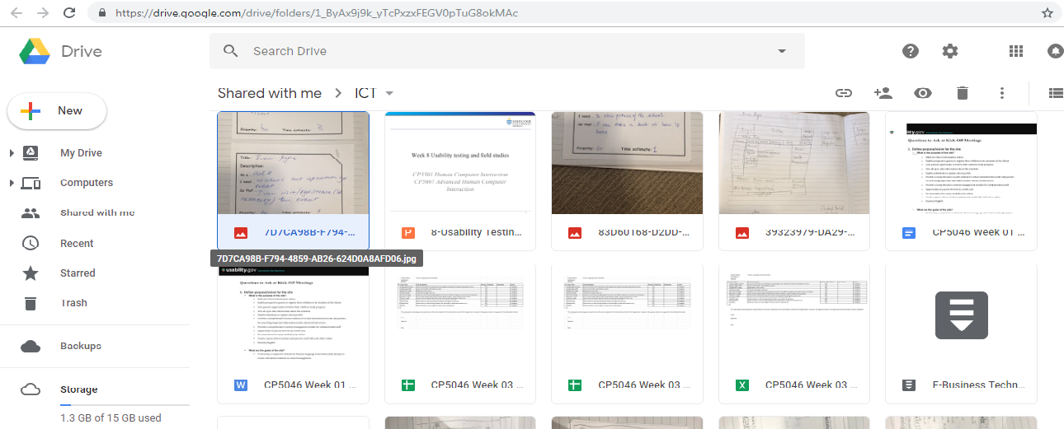

**Project Tools:**

1. **Adobe Dreamweaver:**

It is a comprehensive tool developed by Adobe for web designers. We used Dreamweaver for designing our HTML and CSS pages. The integration with Git makes it flawless. It also supports JavaScript, PhP.

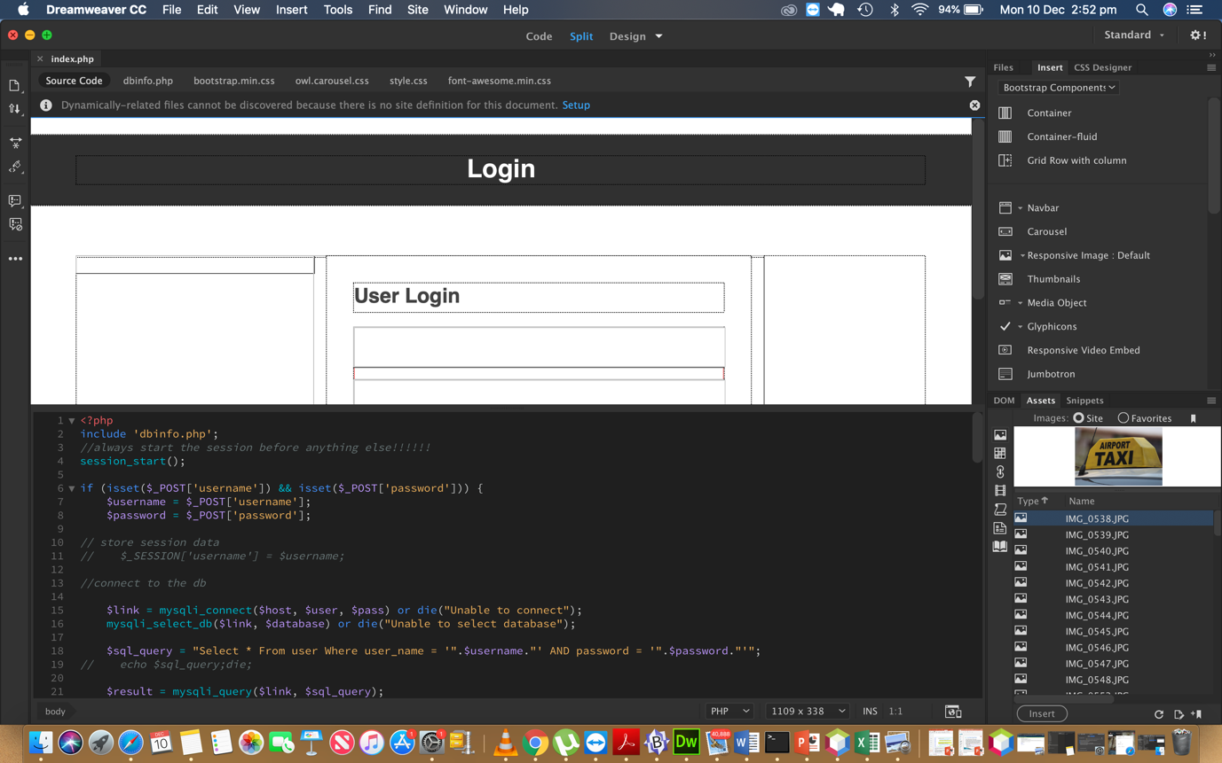

1. **HTML:**

HTML stands for Hypertext Markup Language. It supports tags for various elements of a web page.

1. **CSS:**

CSS is basically a styling language. It works in tandem with HTML for create beautiful webpages.



1. **Microsoft Access:**

Microsoft Access is relational database management tool developed by Microsoft. Access is a part of Microsoft’s overall data management strategy. We use Microsoft Access to write and execute MySQL statements which helps in save and retrieving data from databases.

If a new team member adds up in later phases, they have to install Dreamweaver, Access on their laptops. The previously developed versions can be found on git.

**Milestones:**

**Milestone 1**

|  |  |  |
| --- | --- | --- |
| User story | Priority | Time frame |
| Home page | 10 | 26/11/18 – 05/12/18 |
| Login page(student) | 10 |
| Login page(staff) | 10 |

**Milestone 2:**

|  |  |  |
| --- | --- | --- |
| User story | Priority | Time frame |
| Dashboard | 10 | 06/12/18 – 15/12/18 |
| Enrollment page | 10 |
| Payment page | 10 |

**Milestone 3**:

According to given timeline, the schedule looks little ambitious but, with combination of execution and communication we are sure that we can finish the project on time.

|  |  |  |
| --- | --- | --- |
| User story | Priority | Time frame |
| About Us page | 20 | 16/12/18 – 01/01/19 |
| Contact Us page | 20 |
| Blog(Admin) | 40 |
| Event page | 40 |
| Blog (visitor) | 50 |